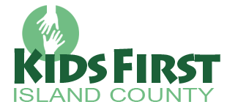

Children who are in foster care are regular kids—but life has been especially hard on them. They have endured maltreatment and they are in foster care to be protected from further harm. Many children remain in foster care for 18 months or more while they await the outcomes of dependency proceedings for reunification with their birth parents. When reunification is not possible, they await adoption by a “forever family.”
Founded in 2009, Kids First is a volunteer-driven organization dedicated to fulfilling the unmet needs of children and youth who are in foster care. The Kids First team aims to build partnerships that link children with recreational, educational, and vocational opportunities in which they can develop their talents, skills, and self-esteem. Kids First programs are tailored to meet children’s individual as well as collective needs.
Our scope of service includes all Island County children and youth who are placed within the temporary care of foster & relative families, or in group home settings, regardless of the county or state where the child has been placed. It also includes all children and youth who are placed within the care of Island County foster and relative parents, regardless of the child’s county or state of origin.
The state of foster care is constantly changing and evolving. No two years — or even months — are the same. As new children enter foster care, others are reunited with their birth parents or are adopted into “forever families.” Still, others await the outcomes of dependency proceedings for restoration of permanence in their lives.
Your support will allow Kids First to expand current programs as well as implement new programs that respond to the emerging needs of Island County children & youth. By virtue of the compassionate response that Kids First purposes receive, children continue to know that they are members of a community that cares.
For more info visit our website Kids First – Island County or our Facebook page. Contact the Kids First team directly at 888.969.4877 or by email kids1st.islandcounty@gmail.com

